PAGES' Flood Working Group (FWG) will hold its second workshop, "Floods in a warmer world: insights from palaeohydrology", from 11-13 November 2019 in Geneva, Switzerland.

Venue
The meeting will take place in the installation of the Department of Earth Science of the University of Geneva, [Rue des Maraîchers 13, Room 001]. The meeting will officially start there on Monday 11th at 13:00 and will end on Wednesday 13th at 15:00.

Logistics
This is an open workshop for around 30 participants. This second workshop of the Floods Working Group constitutes the first official meeting of the second phase (January 2019 – January 2022), which aims to extend the activities initiated during the first phase as well as to enhance the scientific collaborations.

Rational of the Flood Working Group (FWG)
Evidence-based approaches play an important role on defining reliable flood hazard scenarios, especially because model-based outcomes (future projections) encompass so far a high degree of inconsistences and uncertainties.
Paleoflood records from riverine, lacustrine, and marine sediments, botanical, speleothems, and historical documents, analysed with state-of-the-art statistical tools, can provide a more comprehensive understanding of the variability of past extreme flood events and substantially improve the reliability of future flood-risk predictions. All of these data can significantly enhance our understanding of the physical processes and improve flood risk assessments.
The Flood Working Group aims to contribute robust key-data of past floods:
- to include low-frequency high-magnitude flood events scenarios in flood hazard assessment (i.e. flood frequency analysis)
- to anticipate possible impact of future extreme floods.
This is highly relevant, specifically in regions of the world where exposed populations living in floodplains are significantly increasing year-by-year and data are particularly sparse. More info: http://pastglobalchanges.org/ini/wg/floods/intro

Goals of the workshop
The workshop “Flood in a warmer world: insight from palaeohydrology" is the first official meeting of the second phase (2019-2022) of the Floods Working Group. The main goal of this workshop is to favor a scientific exchange around two topics, namely the role of paleofloods on Disaster Risk Reduction (DRR) and better assess changes in flood activities during warmer periods.
In particular, the specific goals are:
- To summary the current state of knowledge related to changes in flood activities between past cold and warm climate phases at regional and global scales. In particular, this session aims to bring knowledge on the following questions:

- Does the flood frequency of the 20th / 21st century higher than observed in the past?
- Does the magnitude of modern (i.e. 20th / 21st century) flood events higher than those observed in the past?
- How evolved the flood frequency / magnitude between cold and warm periods of similar time lengths (Little Ice Age versus Medieval Climate Anomaly or Optimum Holocene versus late Holocene)?
- Does the temperature seem to play a role on the recorded flood frequency and/or flood magnitude?

- To define further strategies to include paleoflood events in flood hazard scenarios, engagement with stakeholders concerning flood hazard and disasters:

- How past flood information change the flood-frequency assessment at local and regional scale?
- Does past flood reveal failures in the conventional flood-frequency assessment?
- How the information gathered from past flood disaster should be communicated to stakeholders and the public?
- How does past flood provide better understanding of the potential response of extreme flooding to climate change for planning and adaption?

Workshop outputs
The FWG is targeting at producing:

- a review paper on changes in flood activity related to cold / warm climate phases that will rely on the workshop material and an upcoming survey and,
- a Science Brief describing how past flood data can contribute to implement more reliable DRR strategies. To this end, key international stakeholders are being contacted: UNESCO and UNSIDR. A collaboration with CRIAS PAGES group will be established as well.

Preliminary program:
Session 1: The added value of paleoflood records in Disaster Risk Management
Session 2: Flood activity in a warmer world: insights from paleoflood records
Session 3: Steps ahead on the creation of a common paleoflood database and general discussion
Monday 11 November: Registration, welcome and session 1
13:00-14:00: Registration
14:00-14:30: Welcome
14:30-15:30: Session 1
15:30-15:45: Coffee Break
15:45-17:30: cont. Session 1
19:00: Dinner and social activity
Tuesday 12 November: Session 2
08:30-10:15: Session 2
10:15-10:30: Coffee Break
10:30-12:15: Session 2
12:15-14:00: Lunch (free time)
14:00-15:30: Session 2
15:30-15:45: Coffee Break
15:45-17:30: Session 2
Wednesday 13 November: Session 3 and Summary
08:30-10:15: Session 3
10:15-10:30: Coffee Break
10:30-12:30: Discussion (cont.)
12:30-13:30: Lunch (catering – if possible)
14:00-15:00: Farewell

How to apply:
To assist the workshop Floods in a warmer world: insights from paleohydrology it is mandatory to complete the registration form template and write an abstract about your contribution, and send it back to juan.ballesteros@unige.ch
Access the template here.
The submission opens 1 June 2019
The deadline for receiving contribution is 1 October 2019

Funding supports:
PAGES (Past Global Changes) is committed to partially support the expenses derived from the travel and accommodation of young researcher, especially coming from third countries. Please specify this request in your registration form, and let us know in the motivation statements why PAGES should fund your assistance to the workshop.

Additional Information:
Visa requirements:
Attendees to the workshop from non-European countries may need a Visa to travel to Switzerland. We ask the attendees to inform yourself of the requirements to enter in Switzerland, both in your embassies or on this: https://www.ch.ch/en/short-term-stays-switzerland/
Accommodation:
Geneva has a multitude of options to stay. The average cost of a single room in a hotel is 120 CHF, but you can find cheaper accommodation from 80 CHF night. However, it is highly recommended to make a reservation in advance. If you need information to book your accommodation, please contact juan.ballesteros@unige.ch

How to reach:
From the Geneva airport: first, take a train to Geneva railway station called Cornavin. Then, you can take either the bus n° 1 (direction Petit-Bel-Air). This bus stop is located outside Cornavin station, just in front of the main entrance. Once you are in the bus n° 1, get off at the station Ecole-Médecine. From there, you have 350 m walk.
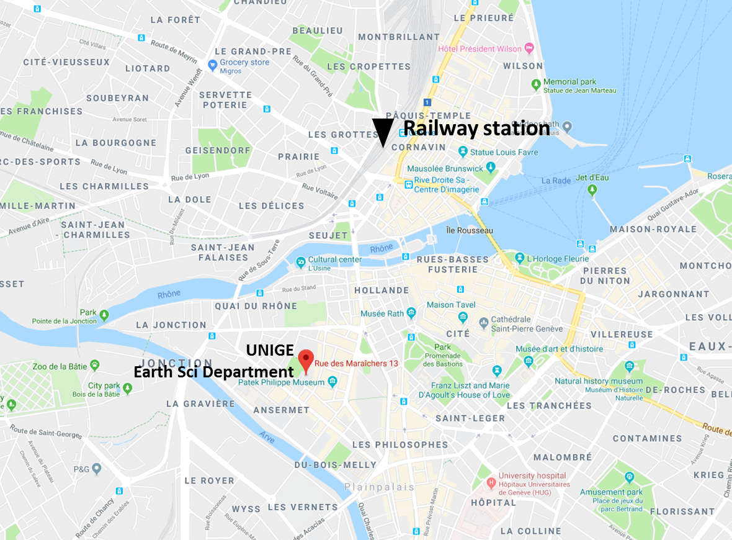
Railway station
Location of the Earth Science Department of the University of Geneva (Rue des Maraîchers 13)

